**Idea Seminar**

**Project-2**

**The University of North Carolina at Charlotte**

**Architecture Department**

**Fall 2021**

**Subham Kumar Sah**

### **Table of Contents**

[Table of Contents](https://docs.google.com/document/d/1Fh5KZ2N3TNCn4d9vkTPZ9VDw2letNYau-x8tAV-nR64/edit#heading=h.hj8afcz1oedp) [2](https://docs.google.com/document/d/1Fh5KZ2N3TNCn4d9vkTPZ9VDw2letNYau-x8tAV-nR64/edit#heading=h.hj8afcz1oedp)

[Introduction](https://docs.google.com/document/d/1Fh5KZ2N3TNCn4d9vkTPZ9VDw2letNYau-x8tAV-nR64/edit#heading=h.iq3nvcmrmjnu) 3

Precedent Study 4

Drawing and Explanation 7

Conclusion 10

### **Introduction**

The goal of this project was to develop a digital artwork based on real data to be displayed in SoA digital displays. The data set chosen is related to the on-demand mobility of Charlotte and its connectivity to the light-rail network and its population density. For this project, I have decided to use the dataset of city joy ride which is the bike-sharing system of Charlotte and Lynx light rail.

I found the names for the bike station and light rail from their official website and I had to manually get their coordinates to make them useful for the exercise.

Ref(<https://charlottejoyrides.com/>,

<https://charlottenc.gov/cats/rail/lynx-blue-line/Pages/Stations-Park-and-Rides.aspx>)

### **Precedent Study**

For this assignment, I tried to understand the logic of some of the illustrations available online and tried to draw the flowchart which the artist may have followed while drawing the illustration.

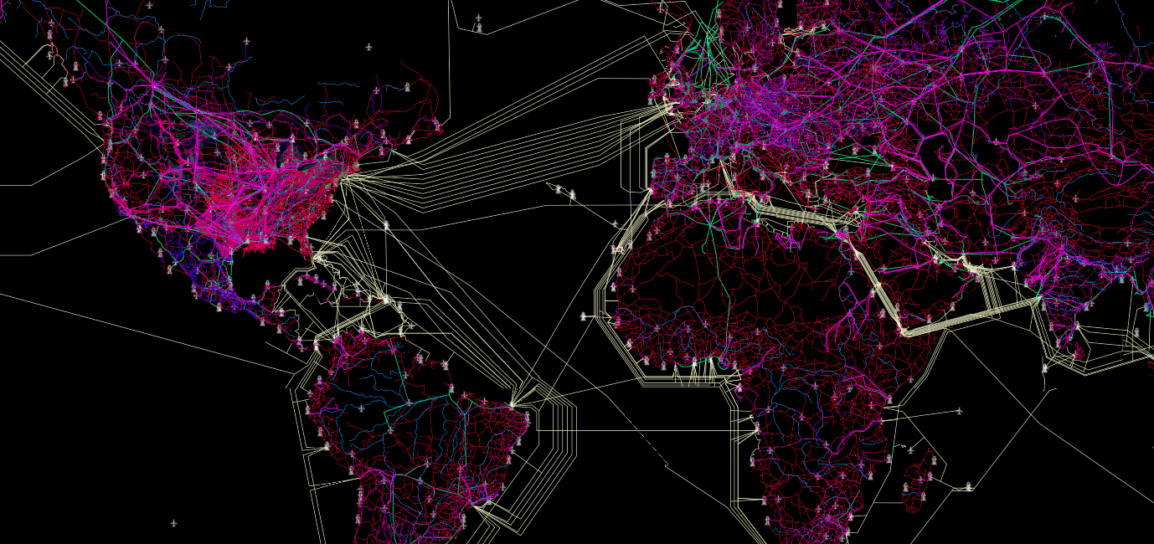

Ref(https://geoawesomeness.com/connectivity-atlas/)

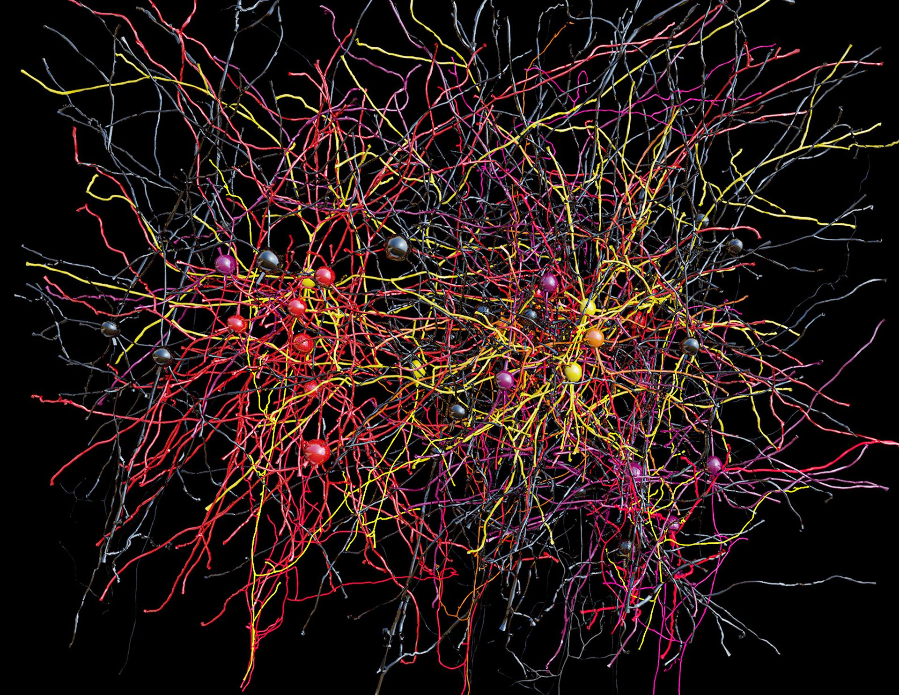

Ref.(<https://nl.pinterest.com/pin/353814114457029561/?amp_client_id=CLIENT_ID(_)&mweb_unauth_id=&simplified=true>)

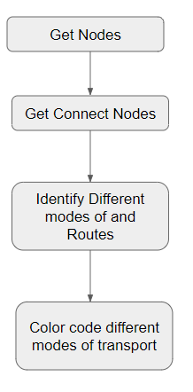

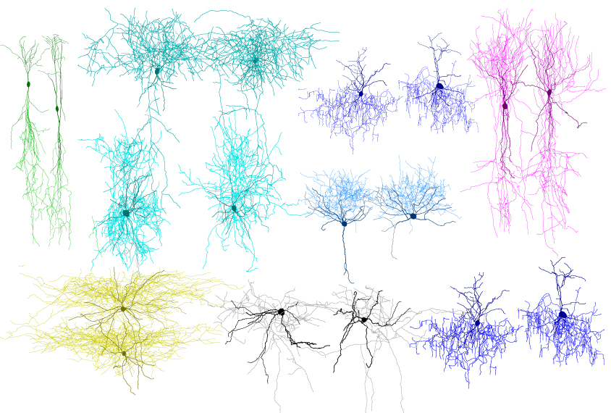

Ref.(https://www.spectrumnews.org/news/toolbox/new-atlas-displays-meticulous-maps-of-brain-connectivity/)

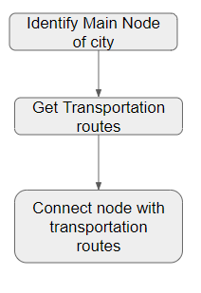

### **Drawings and Explanations**

For this project, I have taken reference from “Dijkstra's algorithm” which provided the shortest path from a particular node to different other nodes.

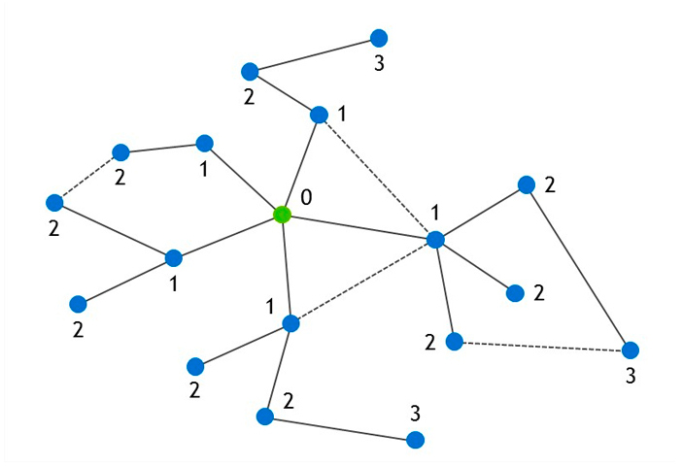

, and my idea is to have an animation which shows/explains to people’s the possibility of going to different bike/light rail stations, when they are present at a particular **bike /light rail station.** so that it would help them make an informed decision about their movement if they would like to go one bike station or the other or it would save their time to take light rail or bike. For example, if someone is at 9th street station would it be easier for him/her to take light rail for the next station or take bikes. Deciding on whether to go to one bike/train station or another sometimes puts users in confusion. That's why I thought of visualizing the networks would be helpful to understand the

I utilized the Custom Preview Lineweights component from the Human library for Grasshopper for the line visualizations. This is a fantastic library for Grasshopper users that want to make their own bespoke visualizations.

Steps followed:

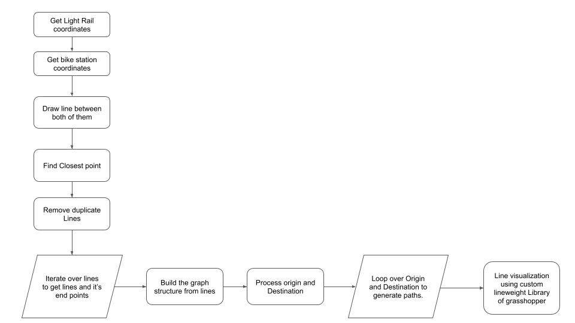

**Path Visualization:**



### **Conclusion**

This project gave me the opportunity to explore different datasets available for exploration in Charlotte and create meaningful visualizations out of them. This project also gave the opportunity to explore the concept of “djskakstra algorithm” which is primarily used for finding the nearest neighbors. Moving forward I hope to use this concept in generating more similar visualizations.